Pyramid of Chephren (Khafre), Middle Egypt
Maxime Du Camp | Photographed December 10, 1849; printed 1852 | Record IMG-NAF0010

1. Original Image
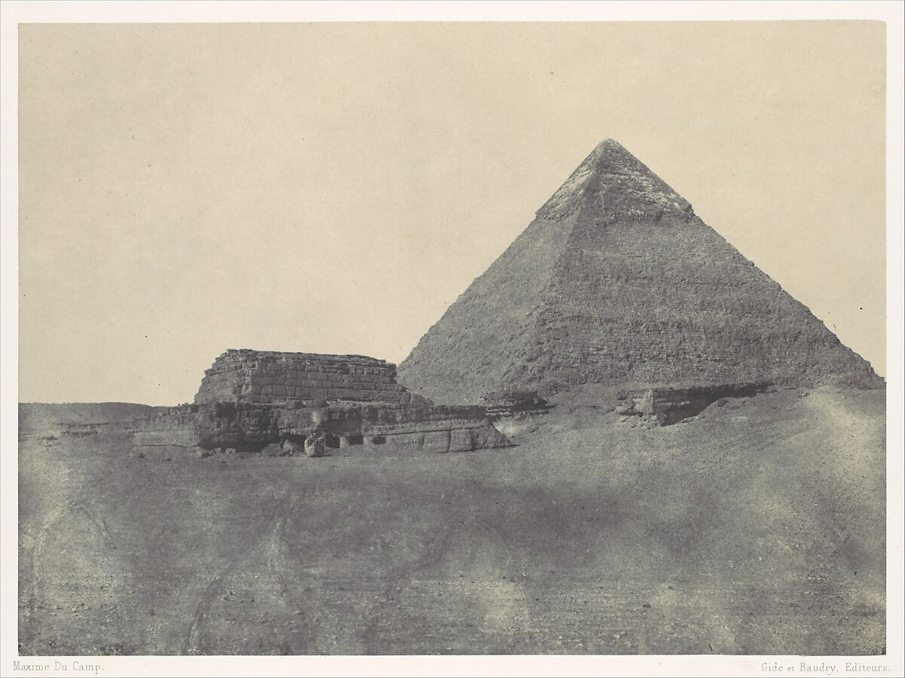
IMG-NAF0010. Maxime Du Camp (French, 1822–1894), Pyramid of Chephren (Khafre), Middle Egypt, Imprimerie photographique de Blanquart-Évrard, à Lille (French, active 1851–55), December 10, 1849, printed 1852, Salted paper print (Blanquart-Évrard process) from paper negative, Mount: 12 in. × 16 15/16 in. (30.5 × 43 cm). The Metropolitan Museum of Art.

2. Record Summary
Record ID | IMG-NAF0010
Original title | Pyramid of Chephren (Khafre), Middle Egypt
English title | Pyramid of Chephren (Khafre), Middle Egypt
Alternative title | N/A
Creator | Maxime Du Camp
Creation date | Photographed December 10, 1849; printed 1852
Country | Egypt
Cultural region | North Africa; Giza
Historical period | Early archaeological and travel photography
Image type | Photography
Medium | Salted paper print from paper negative, Blanquart-Évrard process
Dimensions | Mount: 30.5 × 43 cm
Primary subject | Pyramid of Khafre
Secondary subjects | Desert, low stone structures and blank sky
Source institution | The Metropolitan Museum of Art
Collection or object number (optional) | 1981.1229.6.1

3. Image Description

3.1 Short Description
A pyramid rises near the centre-right of a broad desert view. Low stone structures extend across the left and lower middle ground, while a pale sandy foreground leads toward the monument. The nearly blank sky and restrained tonal range give the architecture a stark geometric presence.

3.2 Detailed Visual Description
The large pyramid forms a triangular silhouette above a low horizon. One face is darker than the other, producing a clear central division. Low rectangular stone walls or ruins form a horizontal band across the left and middle ground. The foreground is an open expanse of pale, uneven sand or earth.
The sky occupies more than half the upper frame and contains almost no visible cloud detail. No people, animals, vegetation or vehicles can be identified. A narrow printed caption appears along the lower mount, although the lettering is too small to read fully at this scale. The image is reduced to several strong geometric elements: the pyramid, the horizontal masonry and the open ground.

4. Formal Features
Field | Analysis
Composition | A dominant triangular form is set against horizontal ruins and open ground.
Viewpoint or camera angle | Distant ground-level viewpoint.
Shot scale | Wide landscape and monument view.
Spatial depth | Open foreground leads toward low ruins and the pyramid.
Lighting | Strong daylight with limited sky detail.
Colour palette | Pale cream, grey and brown.
Contrast | Moderate contrast between masonry, sand and sky.
Visual focus | The pyramid.
Texture | Windswept sand and stone masonry.
Movement or stillness | Static monumental landscape.
Medium-specific features | Matte salted-paper tonality and softened paper-negative detail.

5. Historical Context and Purpose

5.1 Historical Context
Du Camp photographed Egyptian monuments during his 1849–50 journey with Gustave Flaubert. The Met records the exposure date as December 10, 1849, and the printing date as 1852. The Museum also states that the sky was painted out on the negative, making the pyramid more clearly defined against blank space. This demonstrates that early documentary photography could include deliberate manipulation. [IMG-NAF0010-S01] Image Purpose and Circulation

5.2 Image Purpose and Circulation
Probable purpose: Archaeological and travel documentation intended for publication and circulation to viewers unable to visit Egypt.
Current institutional use: Study of early photography, archaeological representation and photographic alteration.

